|  |
| --- |
| Experiment No. 2 |
| Basic Gates Using Universal Gate |
| Name: Rutuja Pednekar |
| Roll Number:47 |
| Date of Performance: |
| Date of Submission: |

**Aim - To realize the gates using universal gates.**

**Objective -**

**1) To study the realization of basic gates using universal gates.**

**2) Understanding how to construct any combinational logic function using NAND or**

**NOR gates only.**

**Theory -**

**AND, OR, NOT are called basic gates as their logical operation cannot be simplified further.**

**NAND and NOR are called universal gates as using only NAND or only NOR, any logic**

**function can be implemented.**

**Components required -**

**1. IC’s 7400(NAND) 7402(NOR)**

**2. Bread Board.**

**3. Connecting wires.**

**Circuit Diagram -**

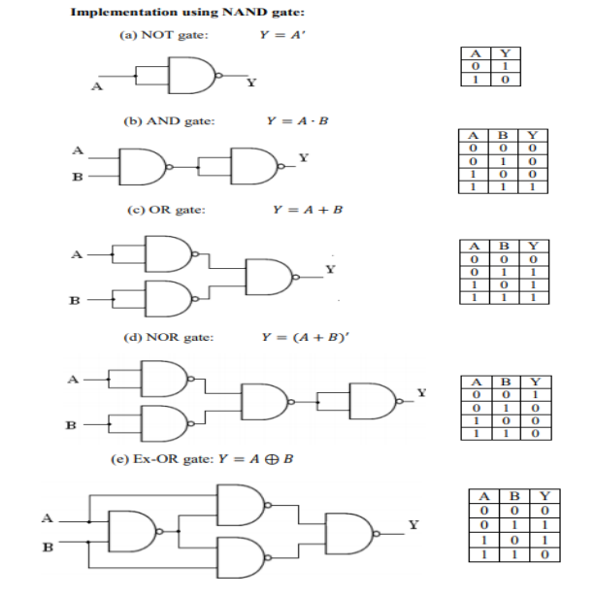

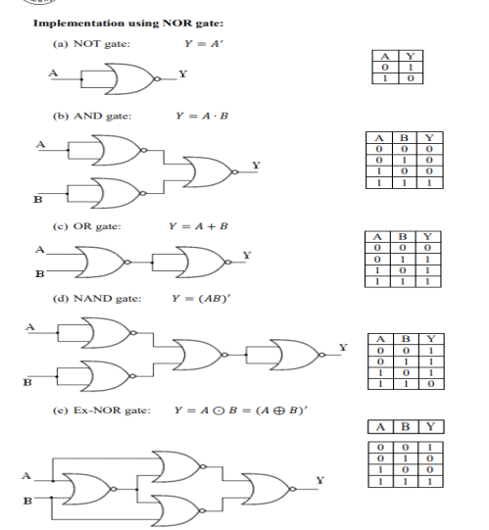

Procedure:

a) Connections are made as per the circuit diagrams.

b) By applying the inputs, the outputs are observed and the operations are verified with the

help of truth table.

OUTPUT:

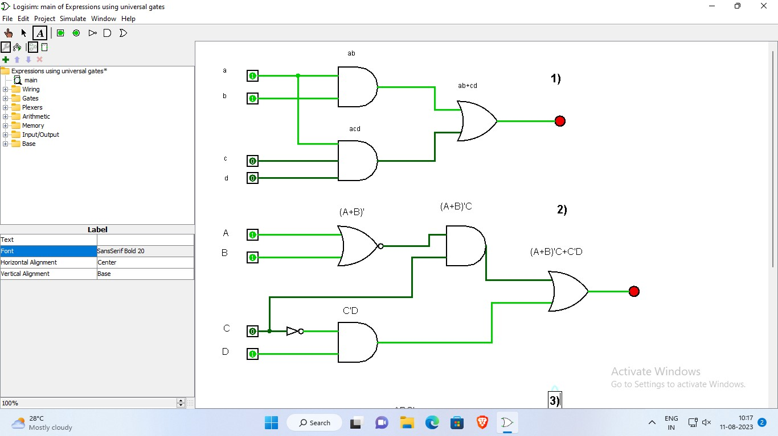

CONCLUSION:

Using universal gates, like NAND or NOR gates, allows for the construction of all basic logic functions (AND, OR, NOT). This simplifies circuit design and leads to more efficient integrated circuits. Understanding and applying universal gates is fundamental in modern digital electronics, enabling the development of advanced computing technologies.